SQL Database

1. If you create the database, then associate SQL servers will be created in the backend
2. SQL Managed instances which is same as on premises SQL from functionality point of view
3. SQL virtual Machines: this is predefined image in which SQL is already installed with windows machines

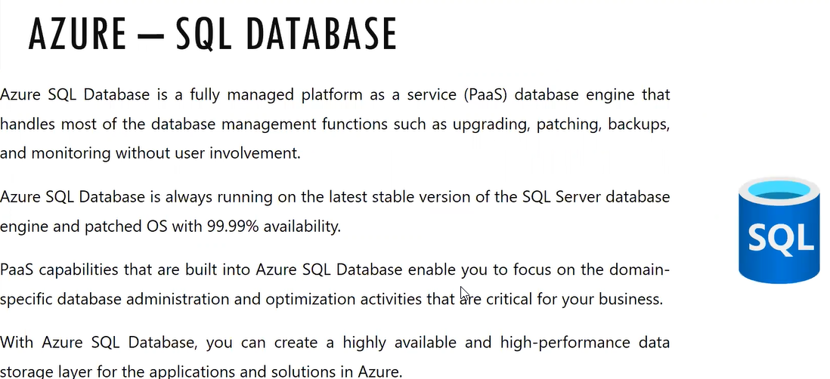

If the database is down then the web application will be down so if we are installing in on premises it should have high availability, CPU and storage

For bring the high availability in the on premises they will bring the cluster or in SQL database there is one group on always high availability group it will do the mirror copy of the database and this mirror copy will be always in synchronization with DB 1 and DB 2

And we see the similar options in Azure sync

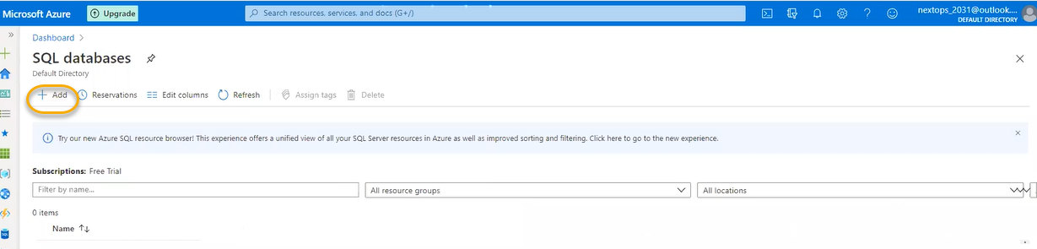

If you are creating the database, then we need supporting VM with out VM we cannot create the DB. Along we need to create the serer. However, we don’t have access to login, to perform activity this is for connection string if you are connecting to DB. If you really need to connect then we need SQL server management studio to be installed in the on premises we will give credentials and URL (nextopsdbst02(server name). database.windows.net/ (database name) NextOpsDBT02) and we will login

Here in the background a VM will be created for DB however for SQL managed instances and SQL Virtual machines we can select the size

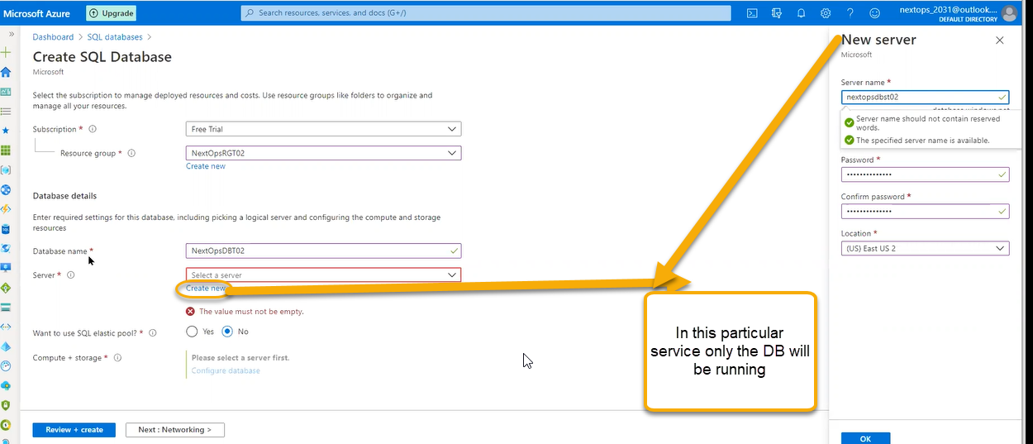

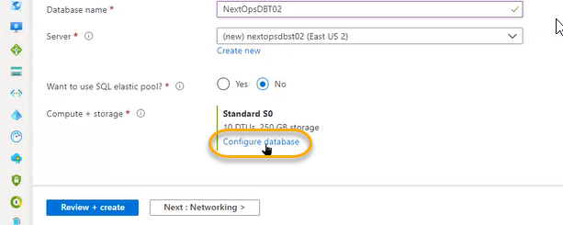

Based on the plan selected how much CPU power we will get in DB we will call it as (DTU- Distributed Transaction Unit) in Azure web apps we call at is as (ACU- Azure Compute Unit)

DTU will define the CPU power based on DTU the DB size will vary

Premium – IO intense workloads: More data consuming services we will use

In on premises earlier based on the number of CPU we have we are supposed to buy that number of SQL license and now it is changed to per core

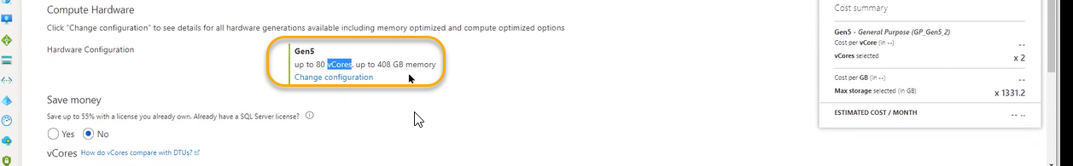

Suppose in the server/system we have 80 cores if we have 4 license SQL limitation will work on the 4 Cores remaining processor will not be used for that core and performance will be impacted if we need performance we need to buy as number of cores are present, we need to buy that number of licenses

So, for 80 cores it will be 4 lakhs cost

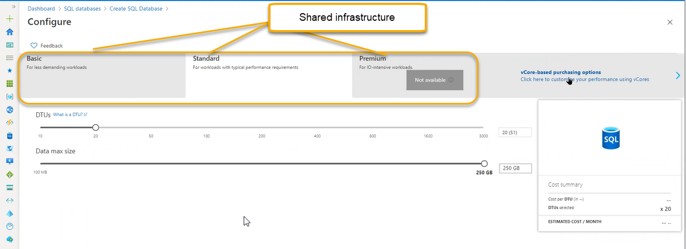

However, for the V cores we are reserving the dedicated physical servers. Gen5 is complete hardware



Click on the Change configuration

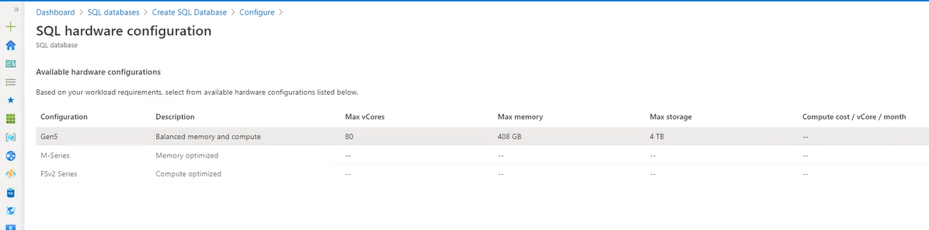

This set up is very costly

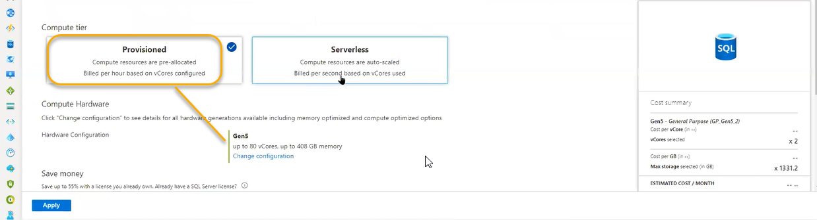

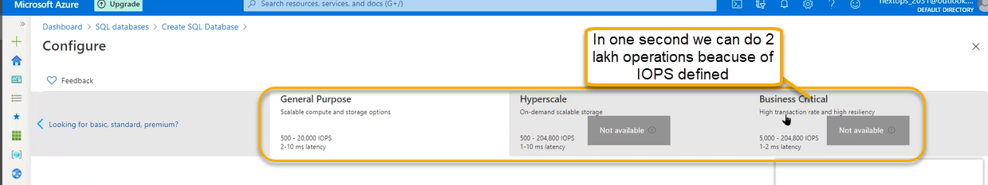

IOPS – Input/output operations per second. Operations per second

In 1 sec it will handle 2 lakh operations

Elastic Pool: In DTU it will bring elastic power and if your selecting elastic pool we need create the pool

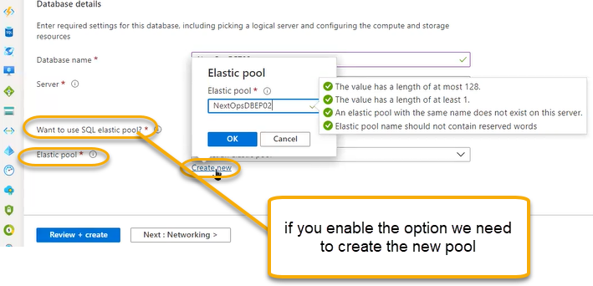

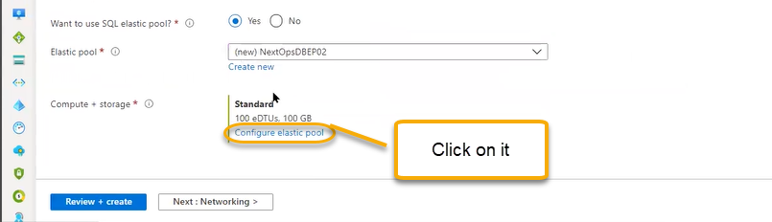

The pricing model will be different in the elastic pool

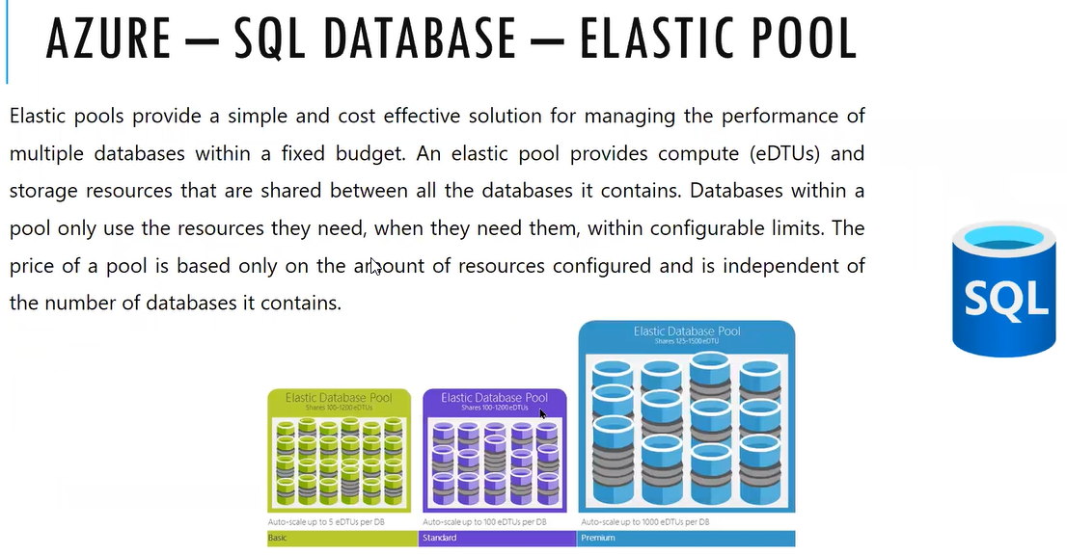

In the pool we can accommodate number of CPUs based on the number of databases we will put in the pool the performance will be generated

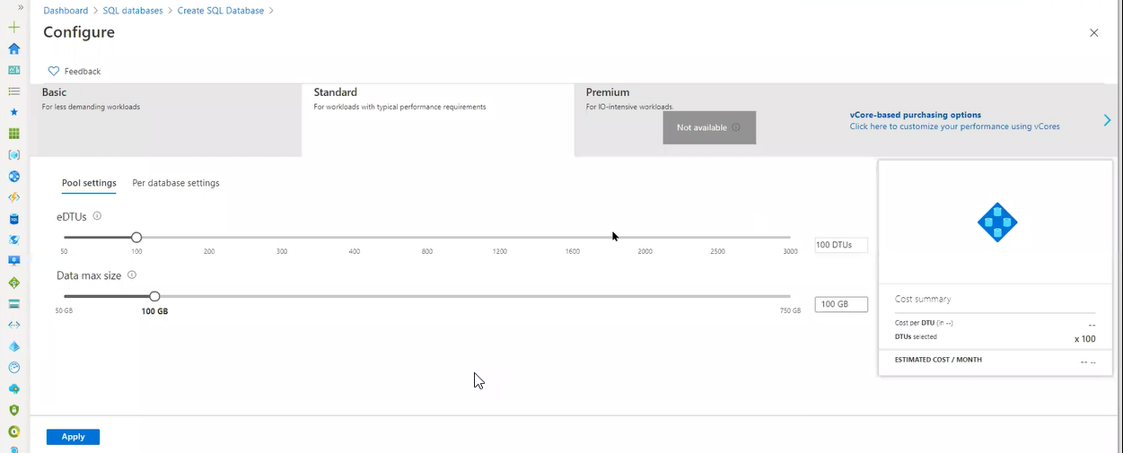

If we select 100 eDTUs and size is 100 GB overall

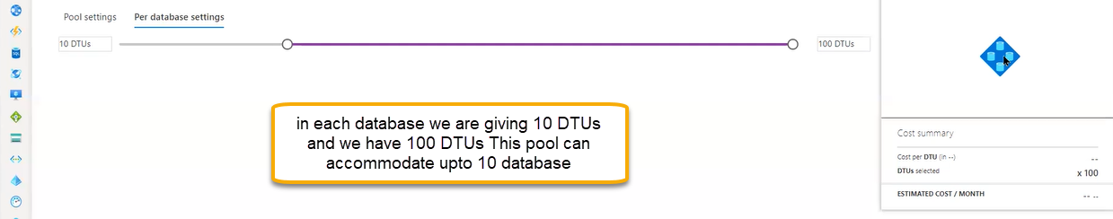

Instance is nothing but database in elastic pool we can accommodate multiple database

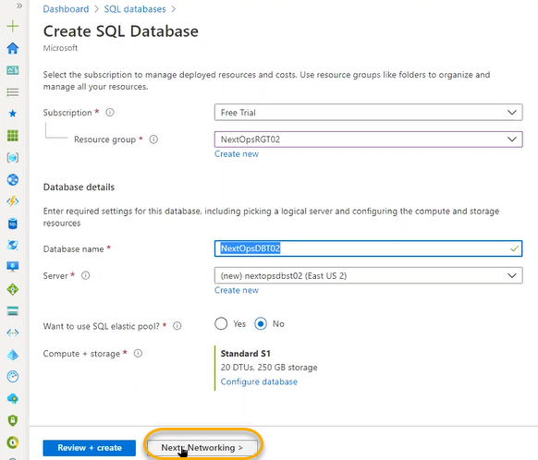

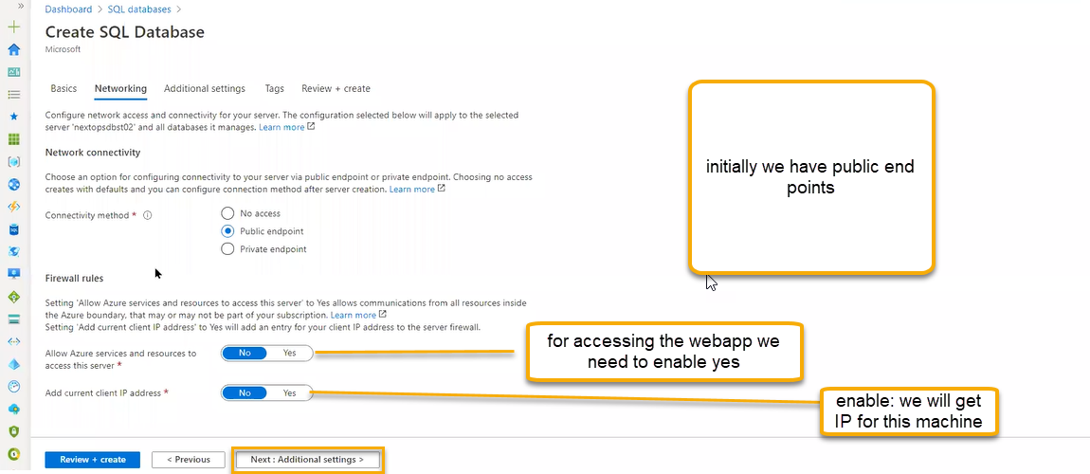

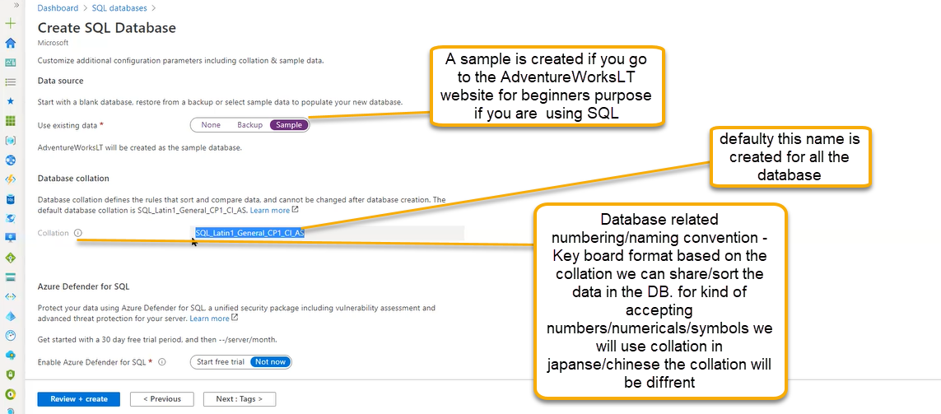

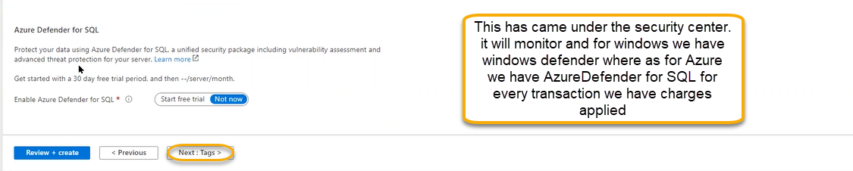

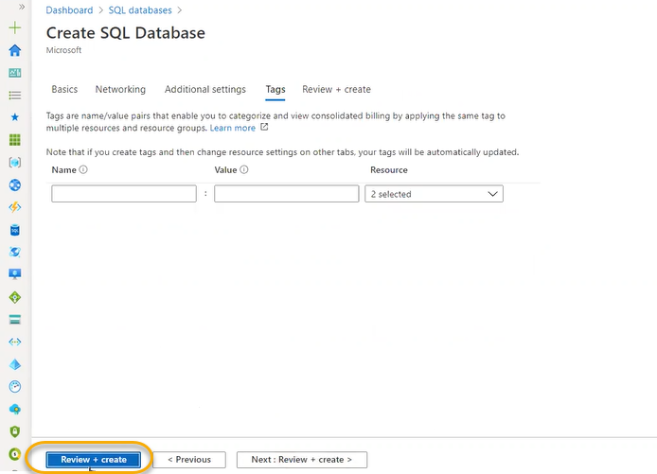

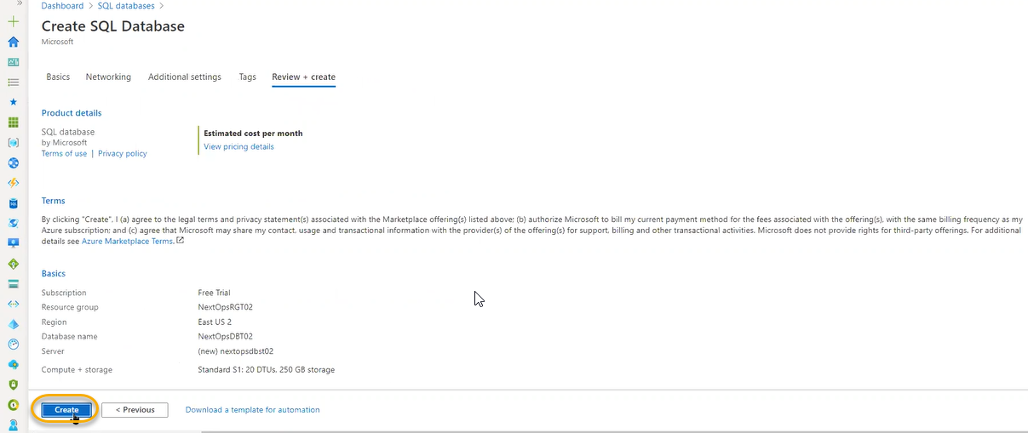

Azure Db and Cosmos DB ( No SQL Db) are natively available in Azure

Oracle and Microsoft have agreed each other so that they azure will support the oracle services

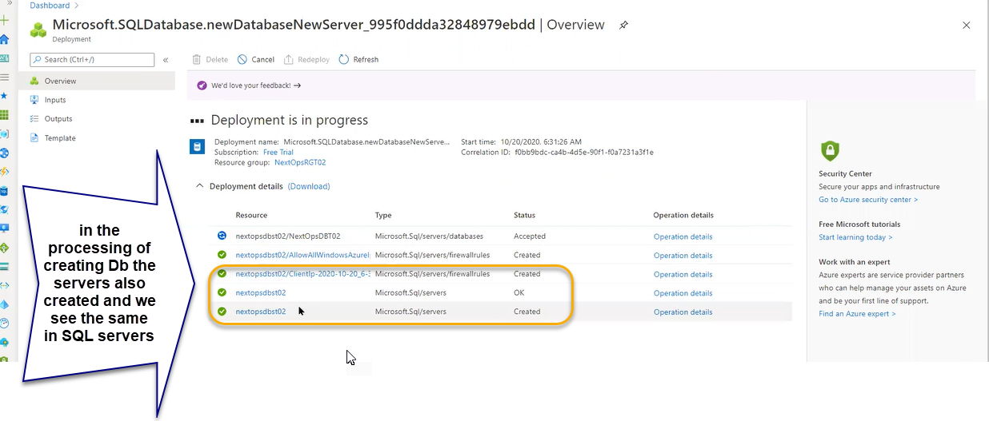

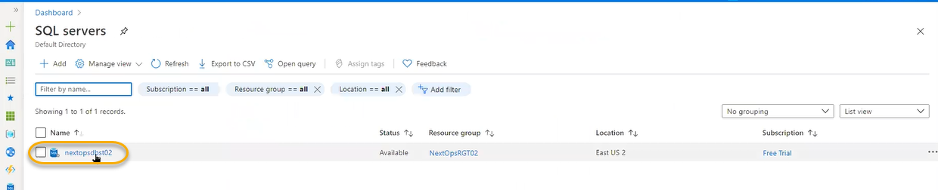

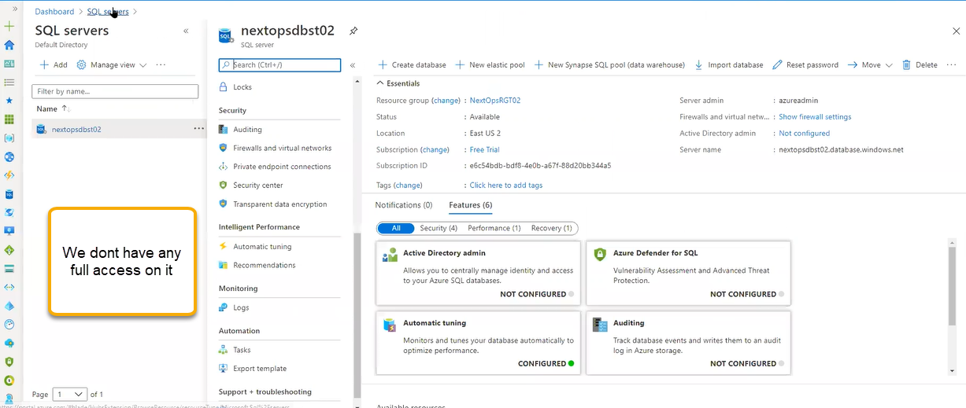

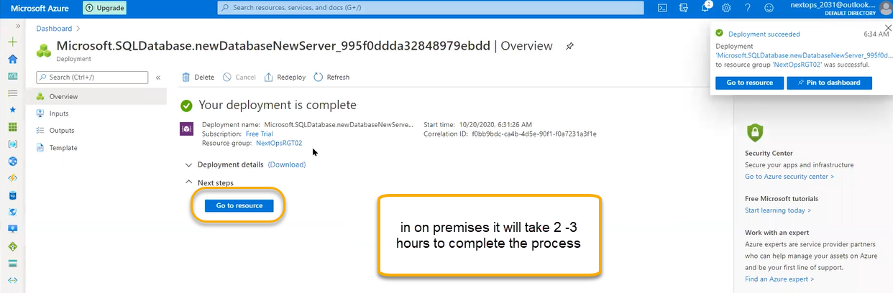

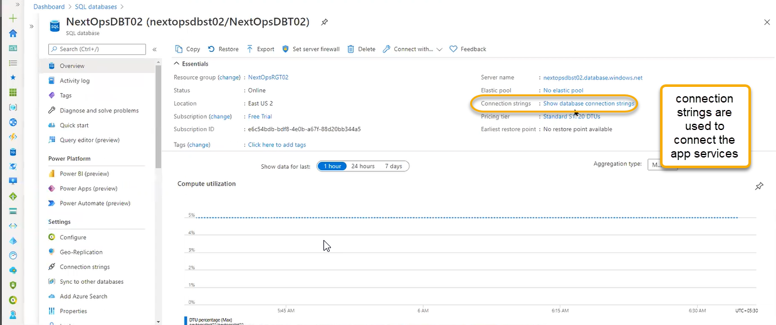

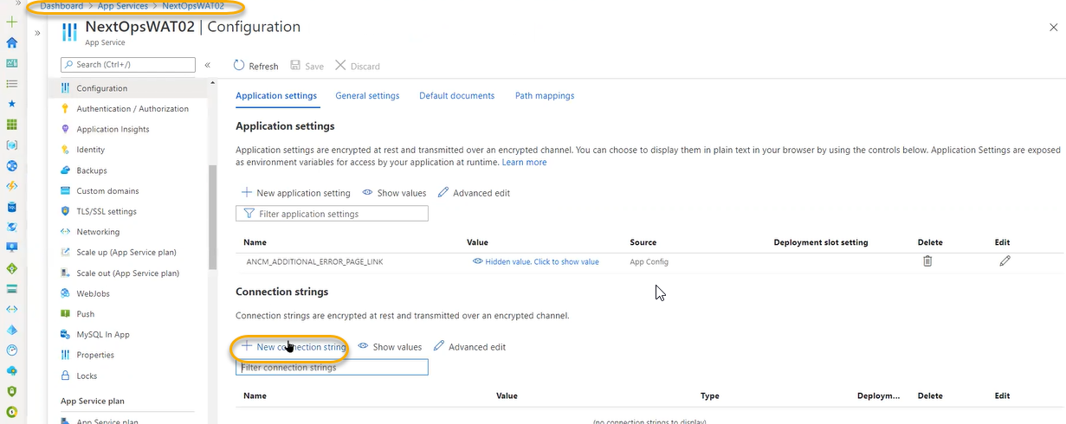

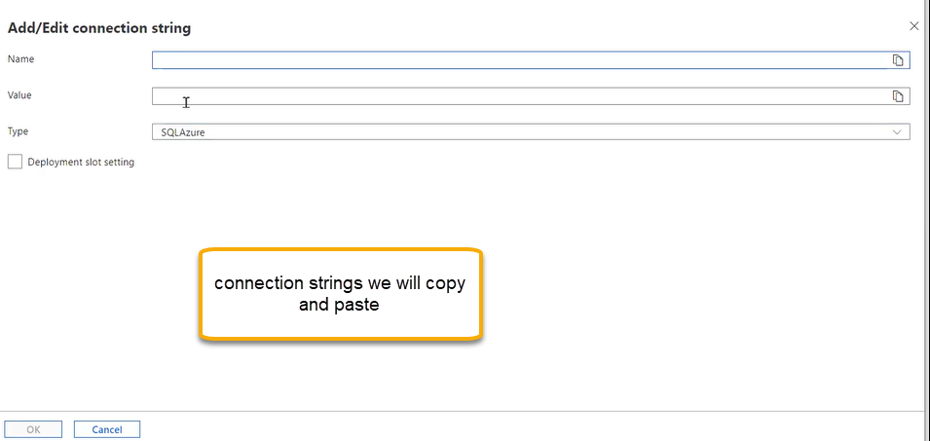

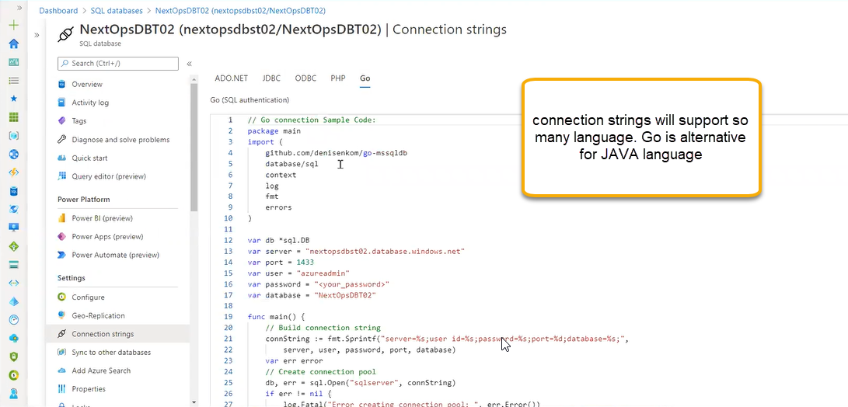

JDBC- Java language

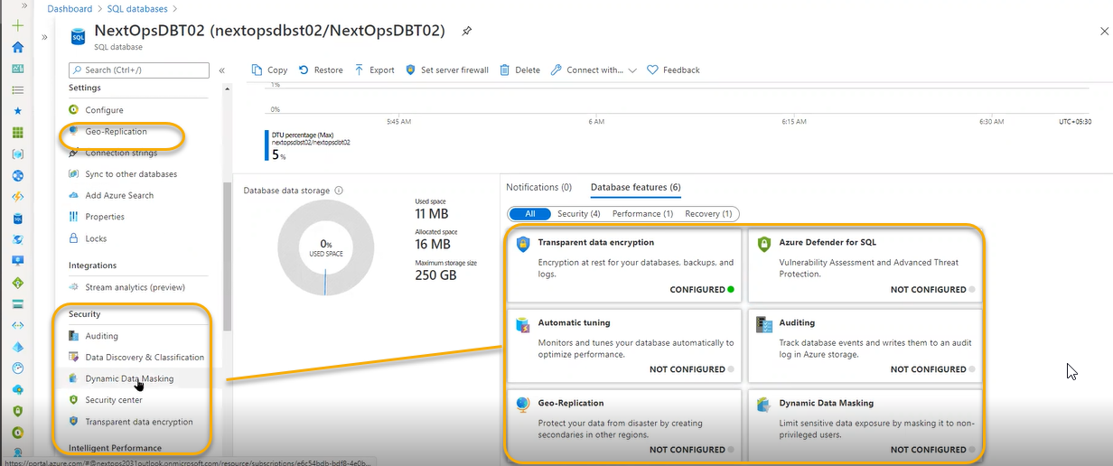

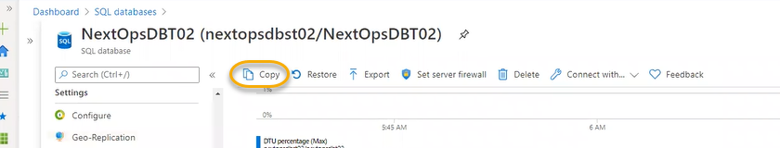

We can create another copy for this DB in the same server or we can create in another server

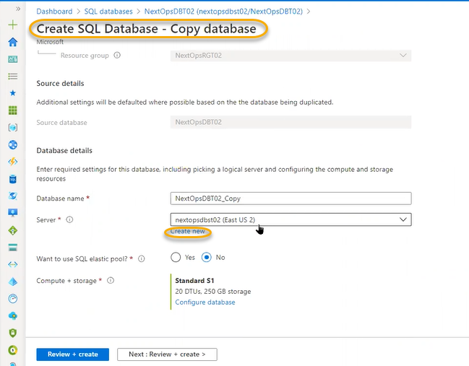

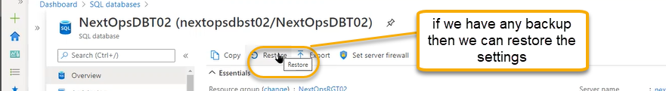

Click on Export

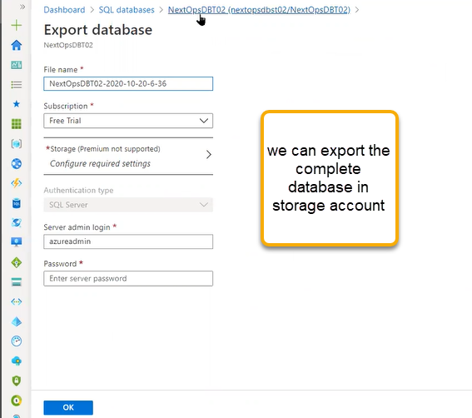

Click on the set server firewall

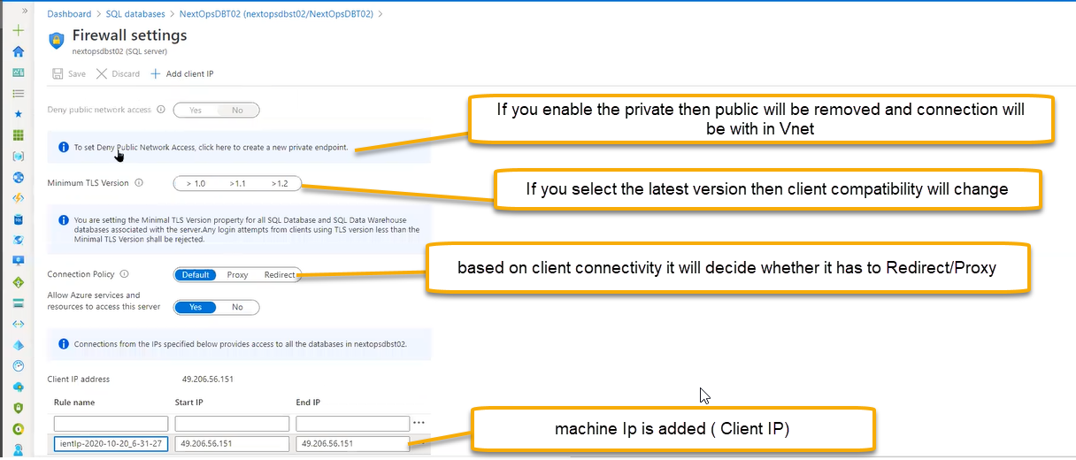

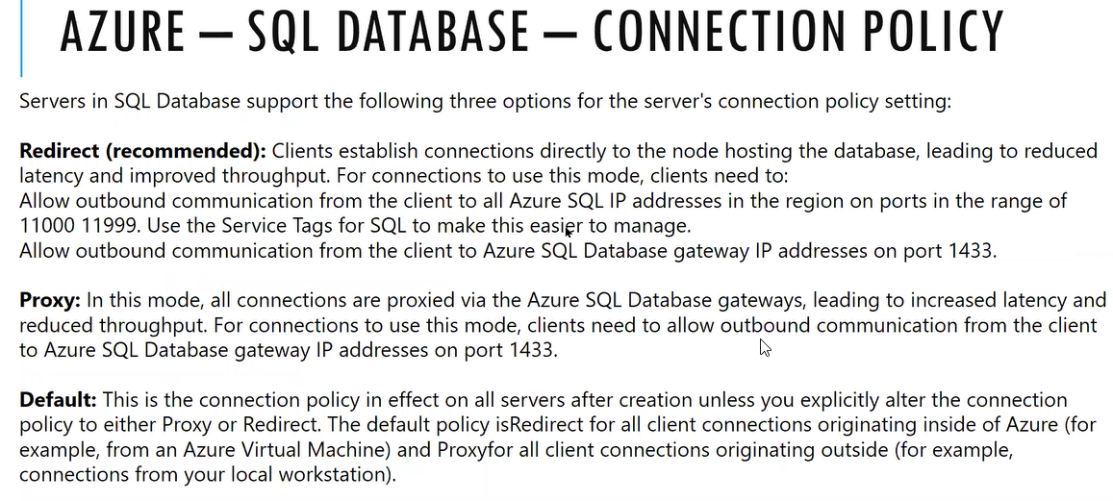

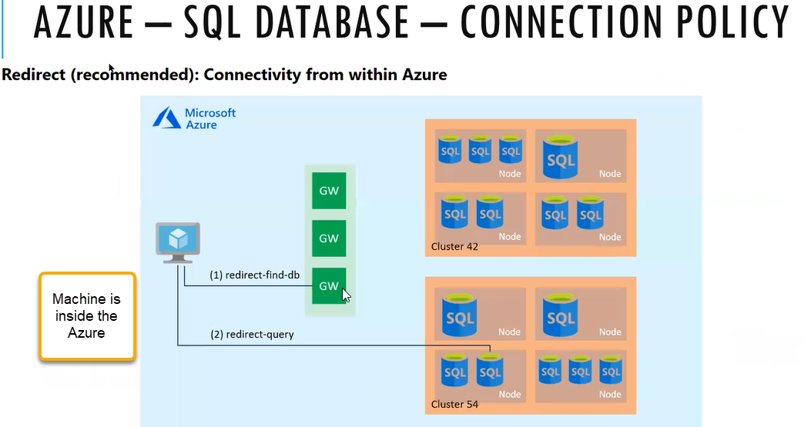

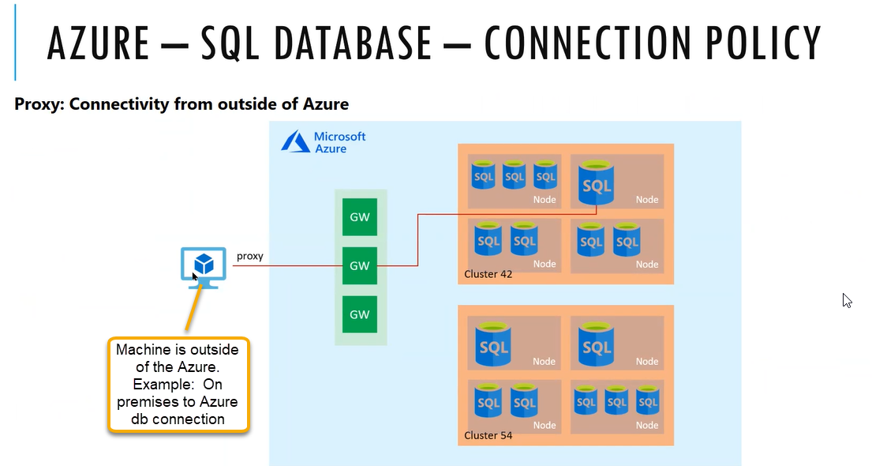



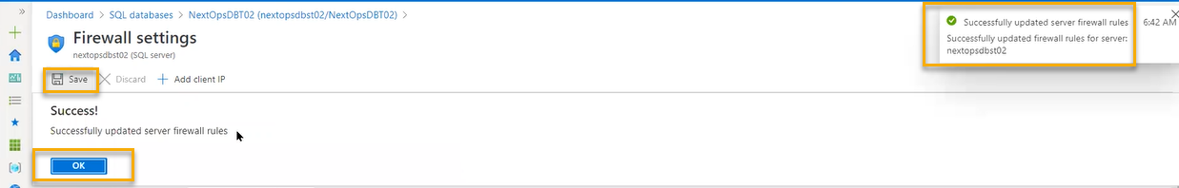

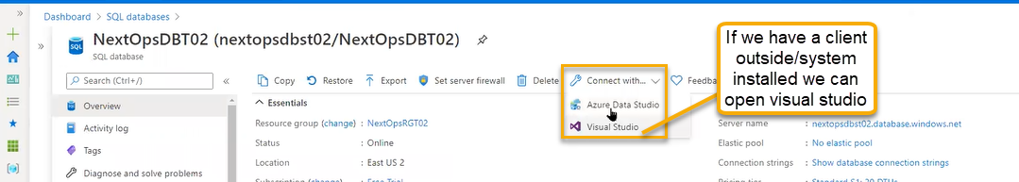

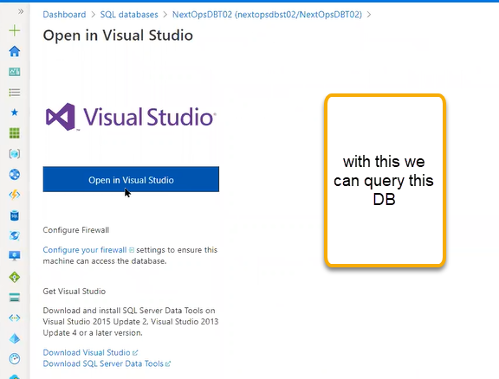

Query Editor:

It is used to edit the sql queries

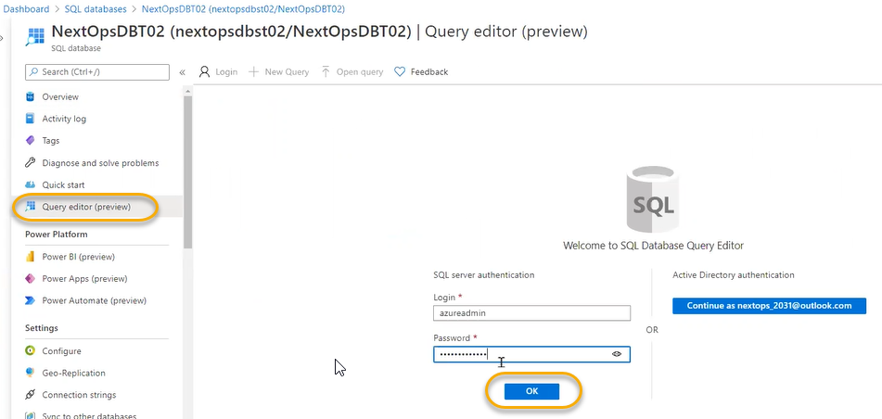

Select any table

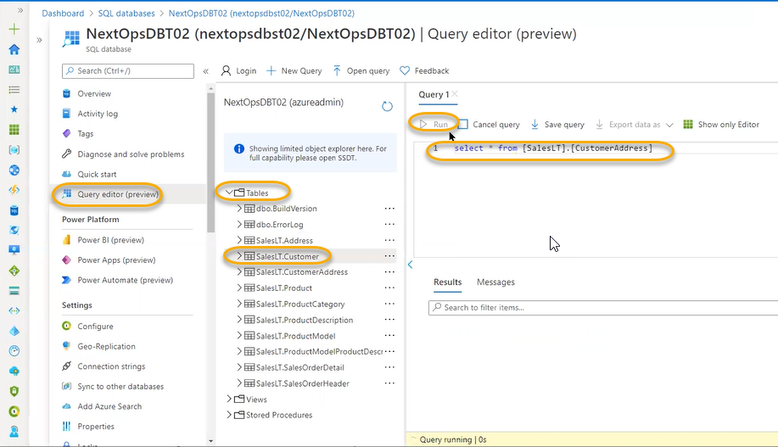

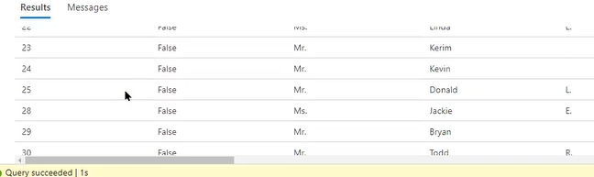

Usually you do in the sql management studio we will connect and do the query

The above query will take upto 1 sec because of simple query if it is big query it will take upto minutes for that we need to tune/optimize

Stored procedures is a kind of script language. Multiple tables join and we will get the script

Power platform( power BI):

It will take the data from database and can bring the data in visualize these are business visualization tools

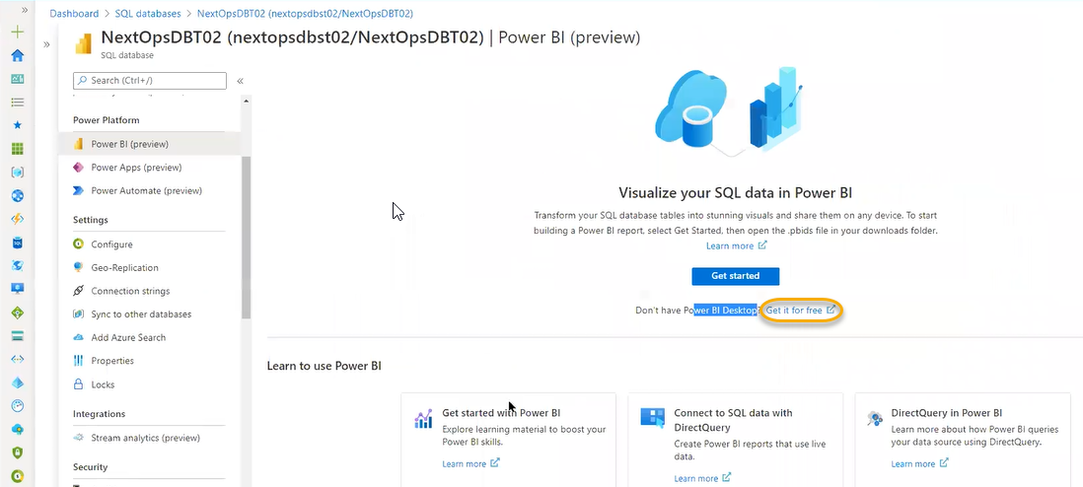

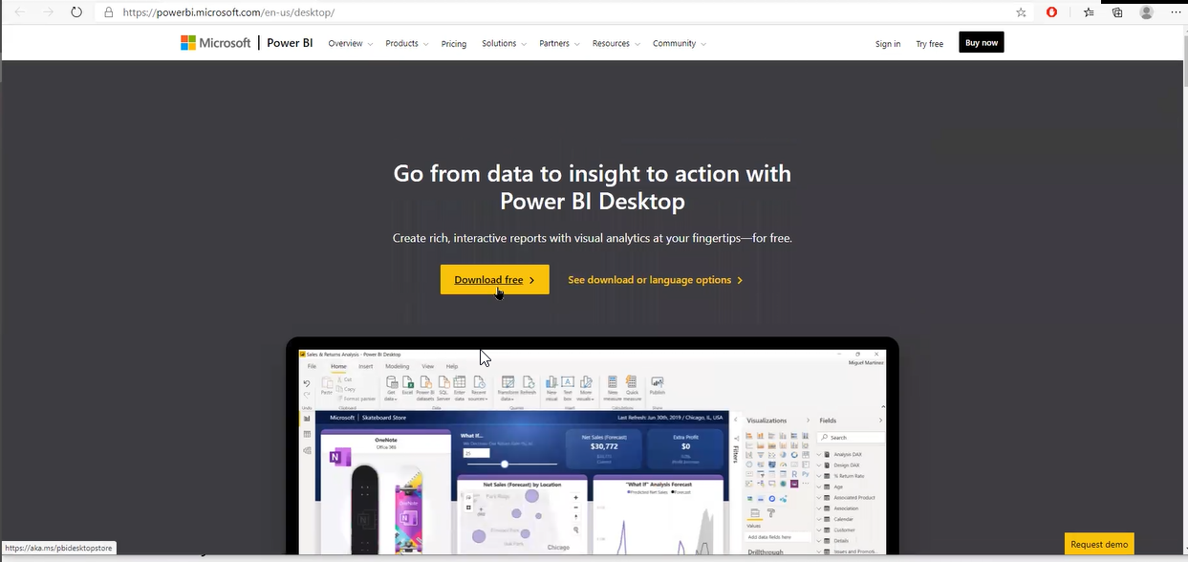

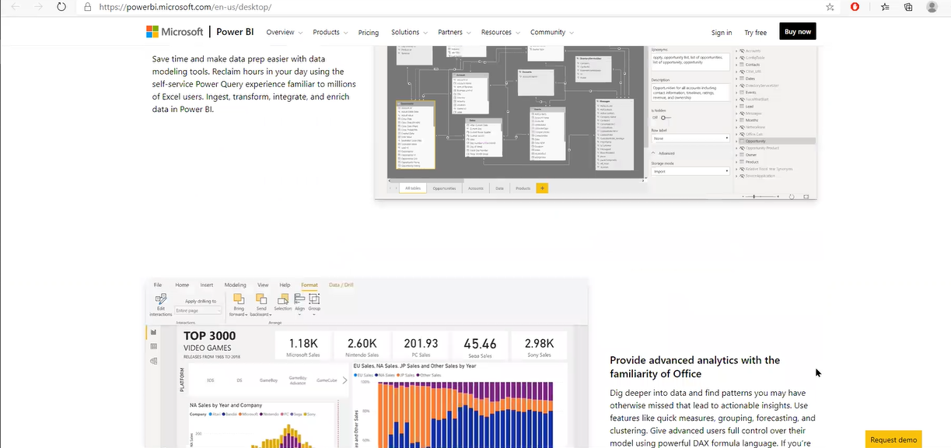

Power Apps

Based on SQL database we need to develop an app

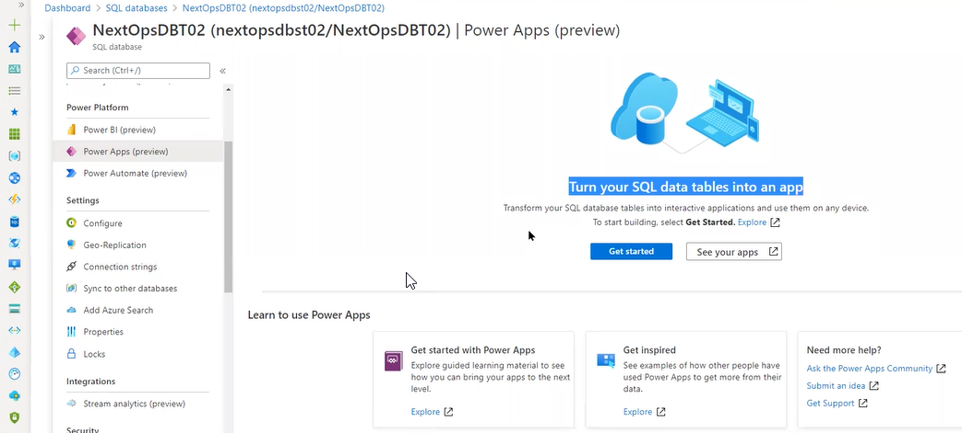

Power Automate:

Kind of maintenance, long running queries, clean up we can use the templates

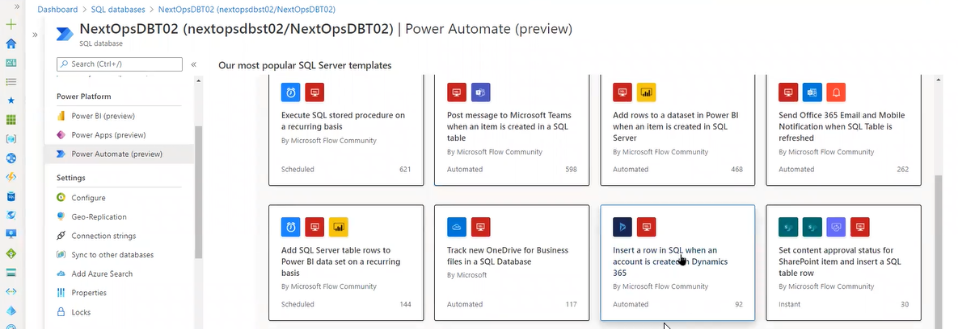

Configuration

What kind of plan we have taken for this particular database

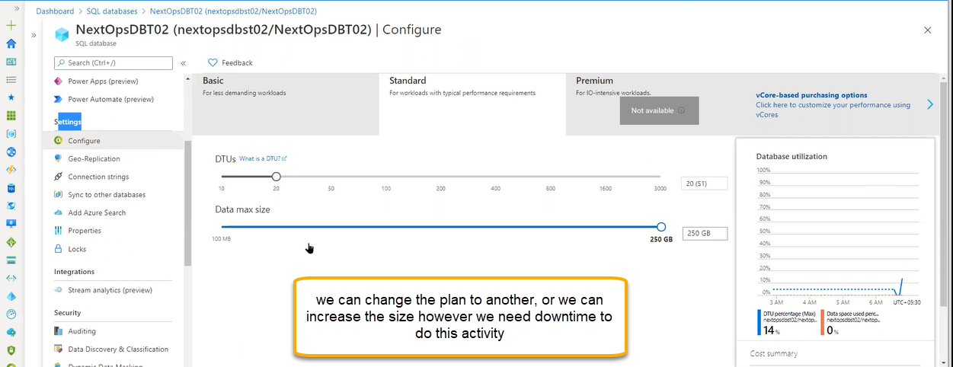

Geo replication

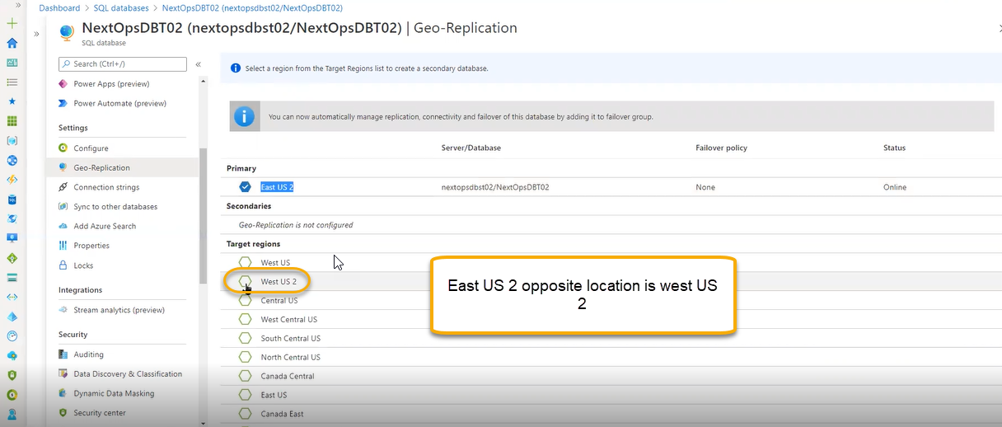

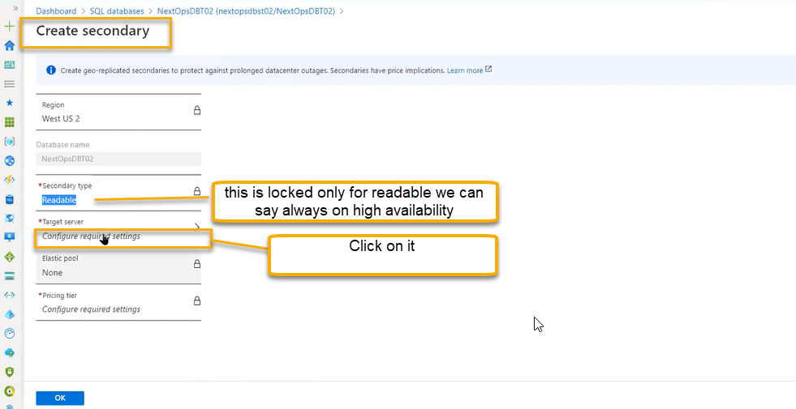

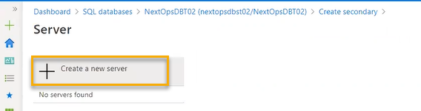

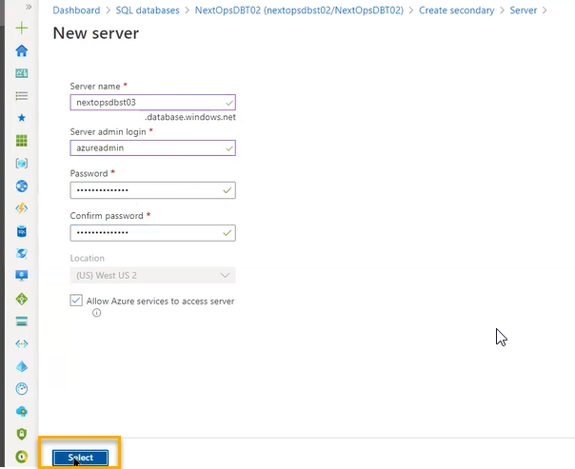

We are creating the database for secondary region which is readable because we can do some operations in off load. If you are doing read write operations, there will be some impact based on the members used and at the same time for protecting the database there will be some backups going and optimization also going and additional administrative activities will be going there at the time performance will be degraded in that scenario we can perform the backups and optimization in the secondary database to avoid degrade to the primary database/ primary database will not be exhausted

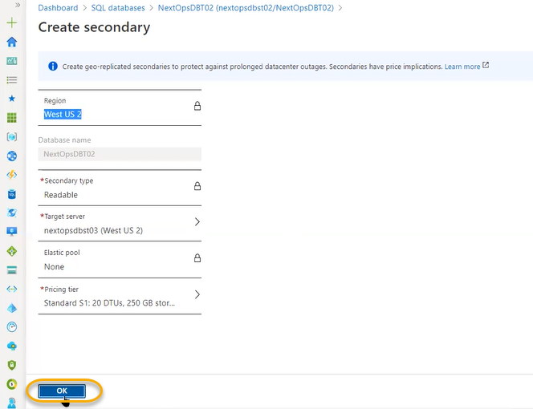

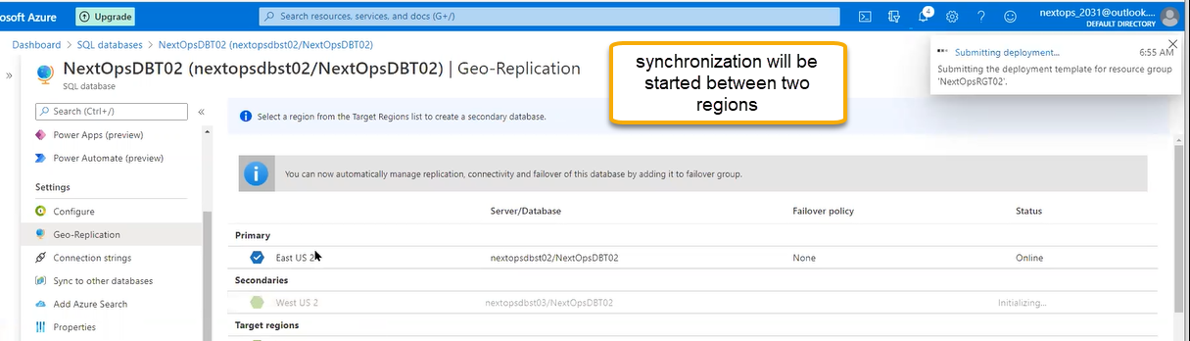

If primary will fail then secondary become the primary and primary becomes the secondary

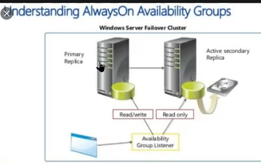

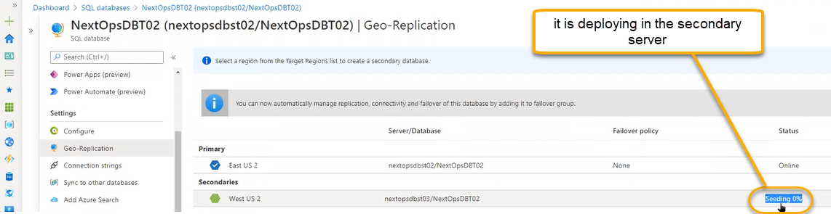

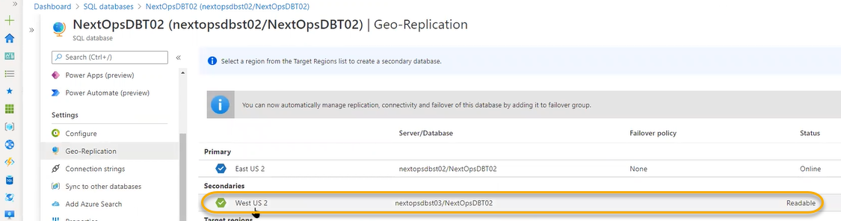

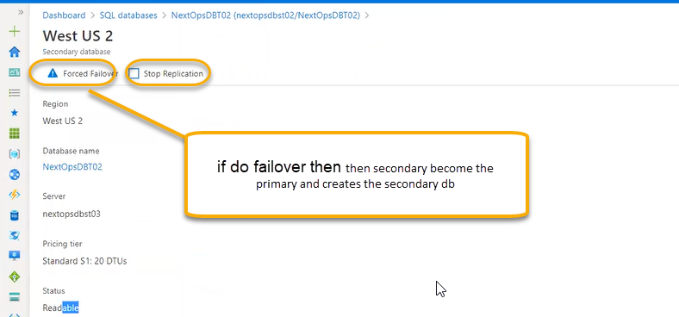

Connection strings

For connecting to the applications, we will use connecting strings

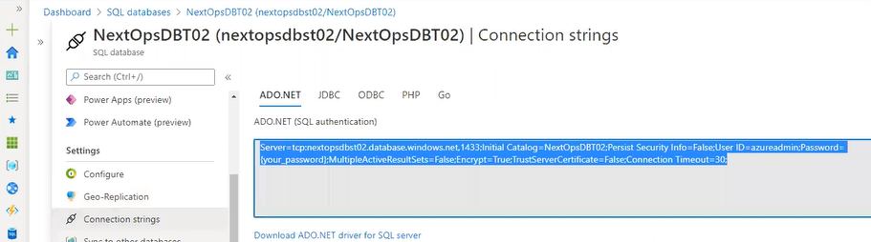

Sync to other databases

These are locally created sync based

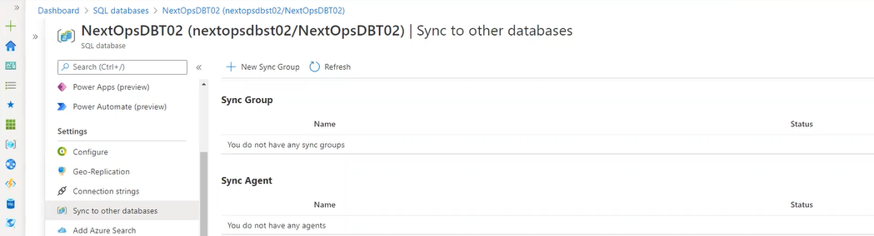

Click on the New sync Group

Similar kind of database we will create in the same group/region whereas geo replication is in cross regions

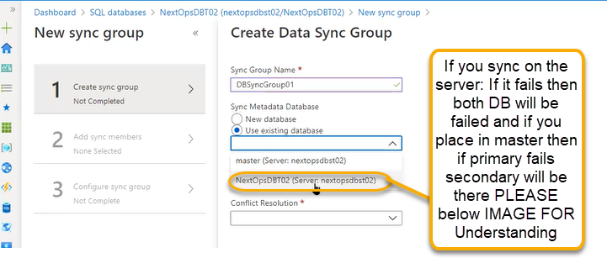



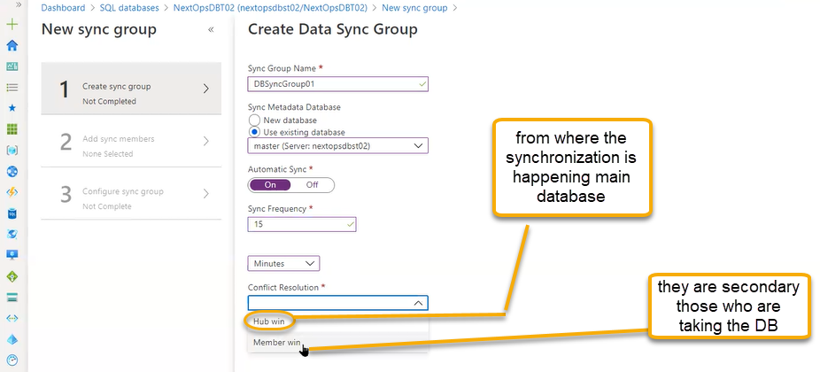

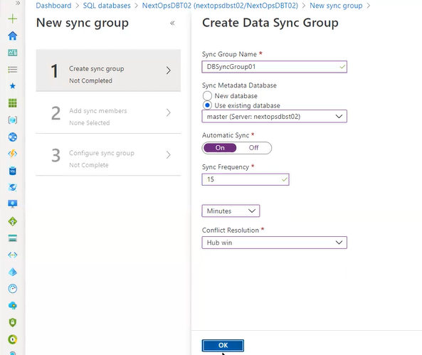

Primary and secondary both are read and write

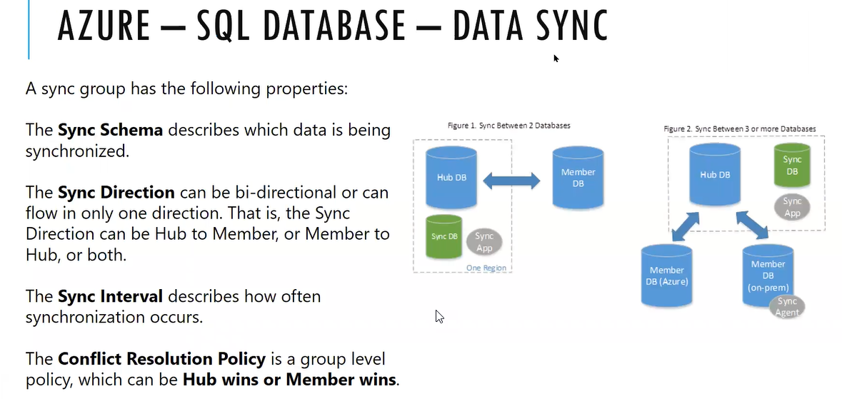

Add Azure search: If you need to bring the search engine to the database we can enable here which we see same in the storage

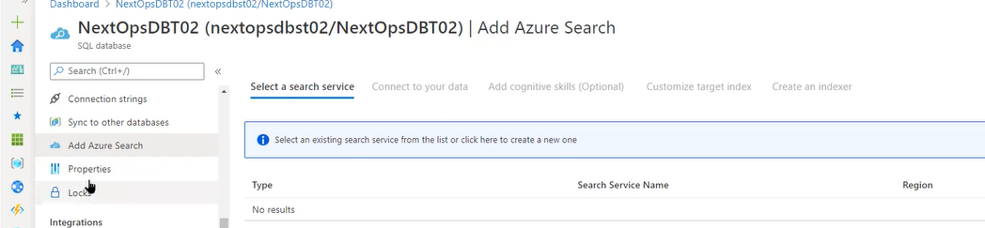

Stream analytics

If we have event hub the data coming from this database completely we can inject to event hub or iot services ( internet of things)

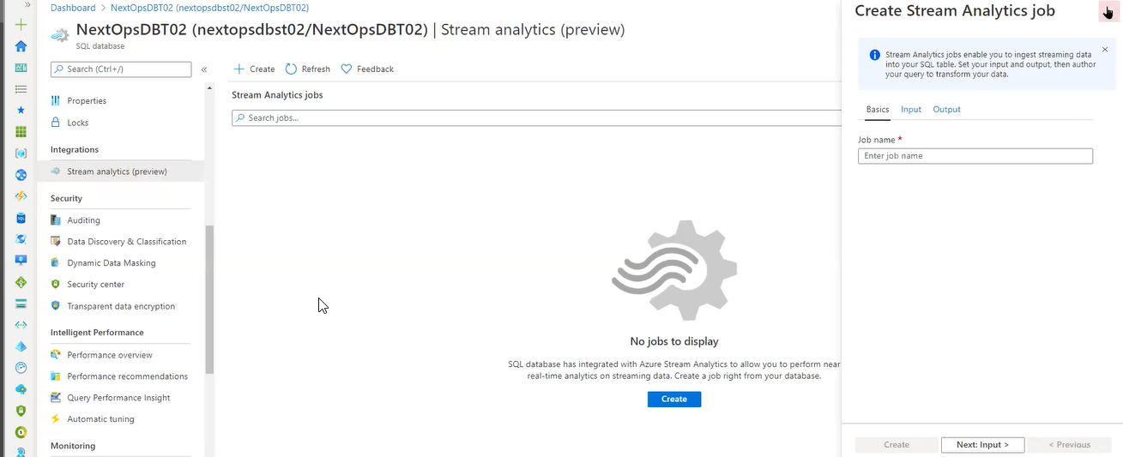

Based on the data ( live data) coming from DB it will analyses and create the analytics

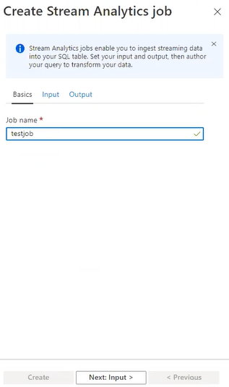

In the Input we can put Event Hub or IoT hub(this is for analytics tool)

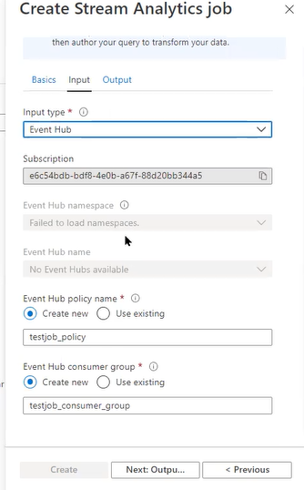

So that data will go output (Event Hub) and we will see the results

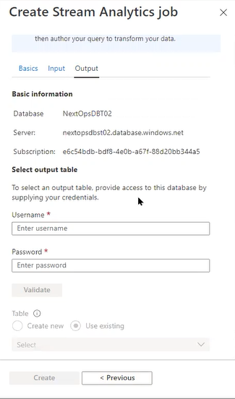

Security/Auditing

Database information is always sensitive

What queries they had run/ what configurations they have changed

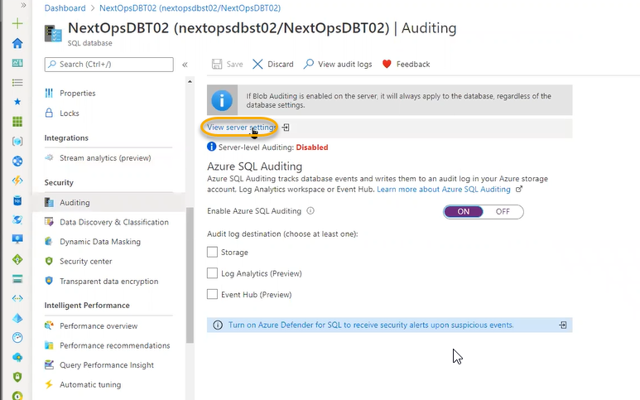

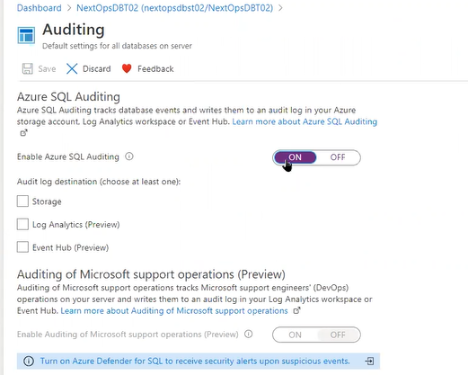

If there any issues based on the log they will debug and we can send the logs to storage account

Data discovery and Classification

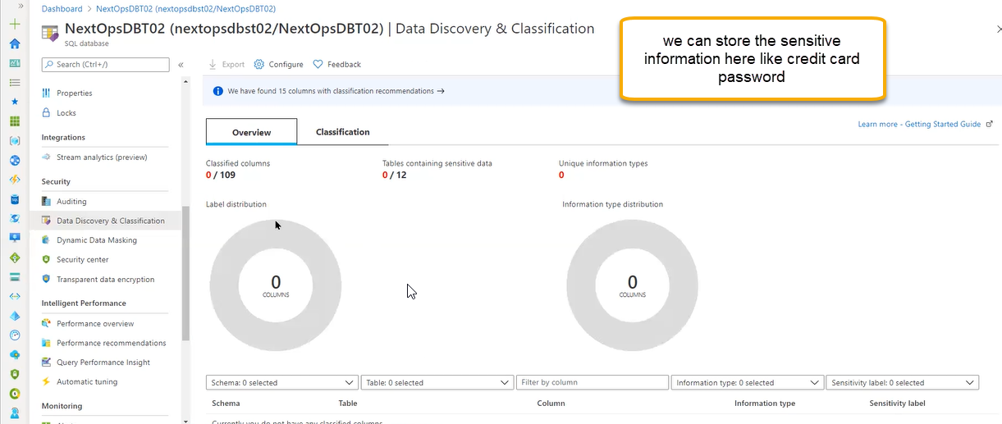

Dynamic data masking

This is used to mask the passwords (when ever if you enter the password it will show ….)

We can achieve here. Usually, database admin will decide the mask function

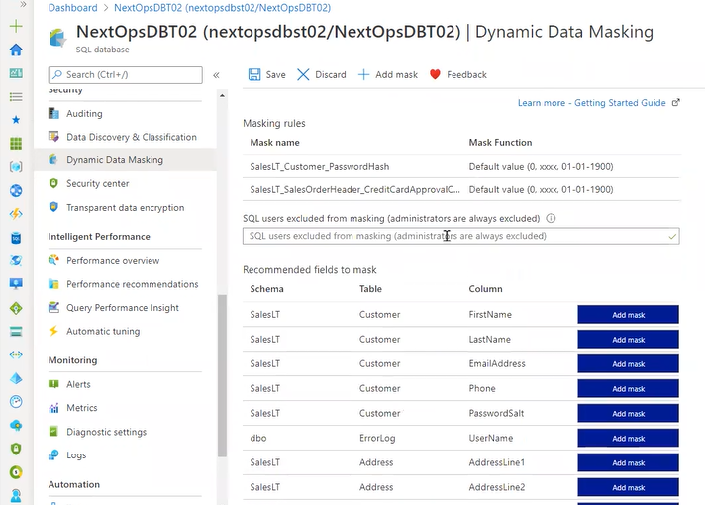

Security center

Checks the vulnerabilities and for every scan they will charge it and it is a costly one

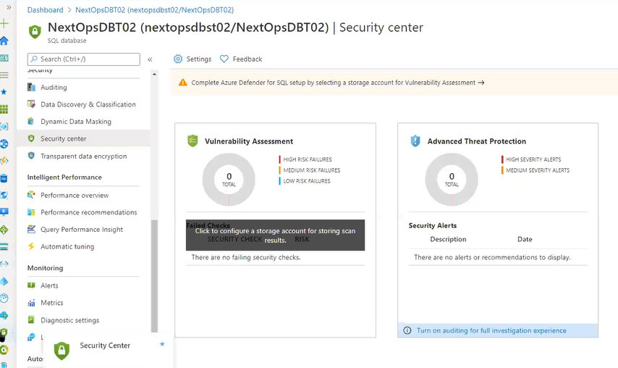

Transparent data encryption: Our data base will be encrypted

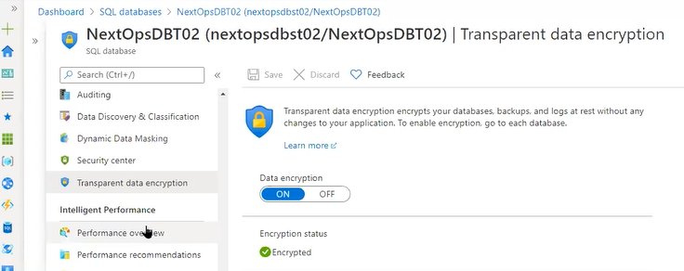

Performance overview: In database we have long running queries (query will take time to retrieve the data) which will degrade the performance we will do the tuning to get the same output by changing the syntax/foreign keys reducing

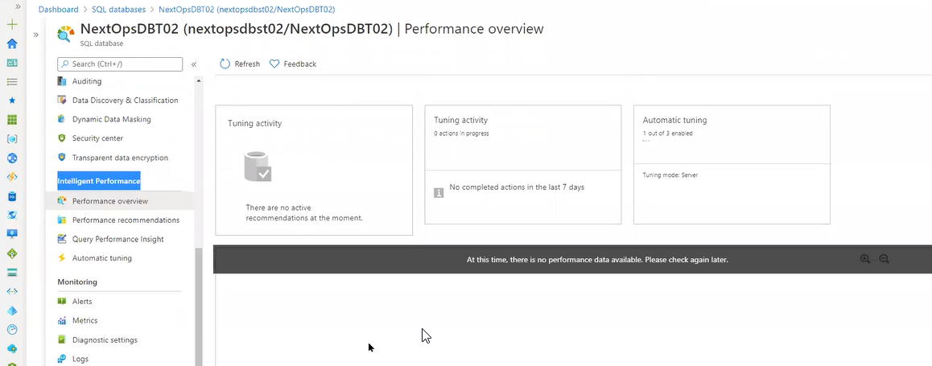

Query performance Insight

We will see the Long running queries here

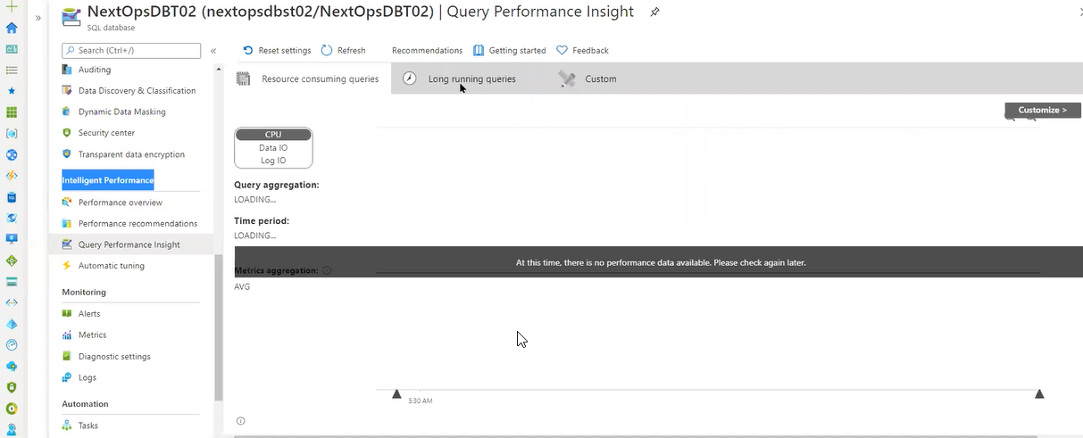

Automatic Tuning with out our intervention it will do automatic tuning

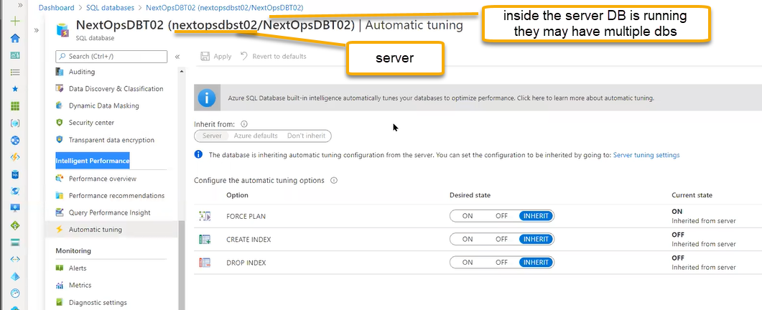

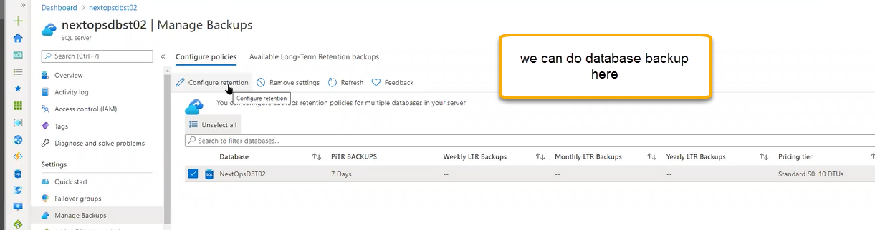

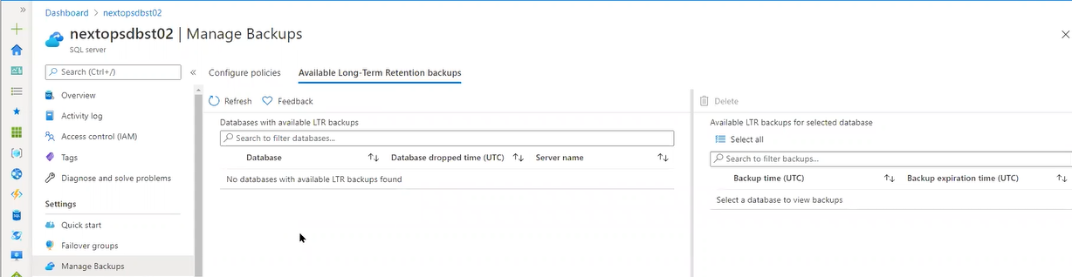

LTR: Long Term Retention

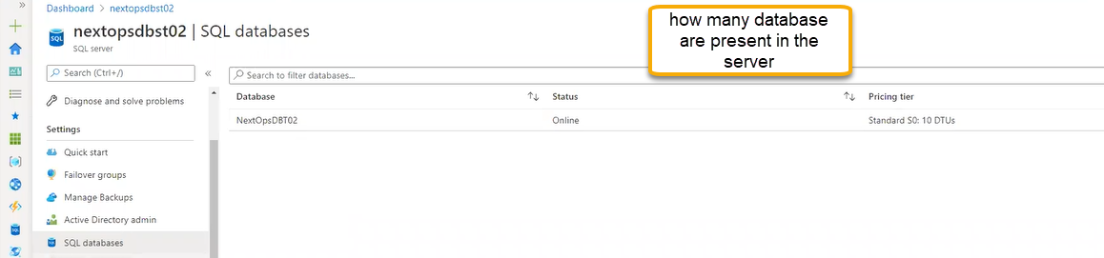

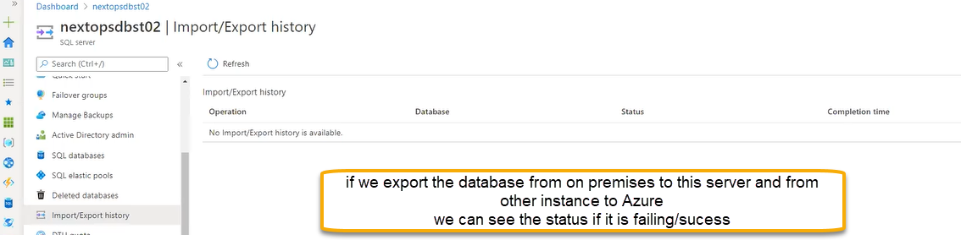

SQL Virtual machines

SQL will be pre-installed

